FEDERATIA ROMANA DE MODELISM
ROMANIAN MODELLING FEDERATION
Member of FAI-CIAM, NAVIGA, FEMA, EFRA
Str. Calea Piscului nr. 10, Sala Polivalentă, cam II-15,
OP-6, CP-56, sector 4, Bucuresti - ROMANIA
Tel./Fax: +4021.316.24.54; +4031.805.74.71
Web : www.frmd.ro ; E-mail: office@frmd.ro

2017 FAI F1D European Championship
for Indoor Model Aircraft

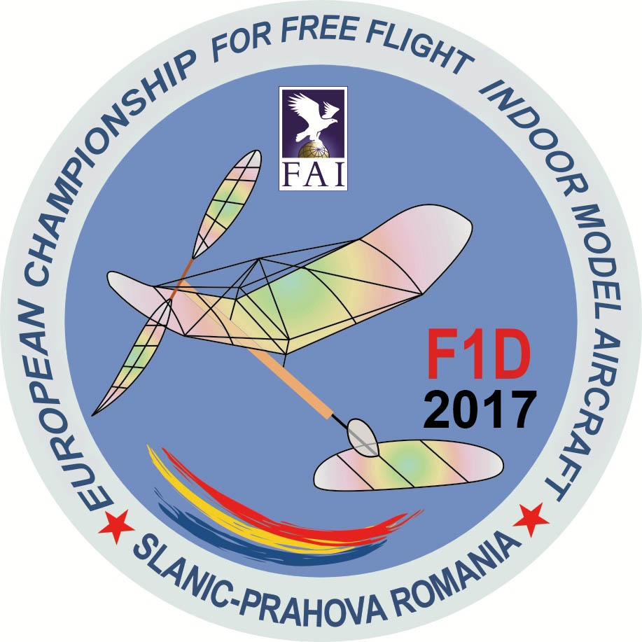

Bulletin 1 - 14th November 2016

Slanic Prahova – Romania

Tuesday 14th of March 2017 (Opening Ceremony)
Friday 17th of March 2017 (Closing Ceremony)

ORGANIZERS: The Romanian Modelling Federation,in co-operation with the Salt Mine Slanic and the local authorities.

DATE: 14th-17th of March 2017

VENUE: The Salt Mine Slanic, district Prahova, where the 1970, 1982, 1994, 1998, 2000, 2002, 2004 , 2006, 2014, 2016 W.Ch’s and the 1973, 1991, 1997, 2015 E.Ch’s took place.

RULES: The F.A.I. Sporting Code Sections A, B and C of the 2017 CIAM General Rules document.

NATIONAL TEAM: each national aeroclub/federation may enter a team consisting of:
- team manager,
- team manager’s assistant,
- maximum 3 senior competitors,
- maximum 3 junior competitors,
- 2015 reigning European Champion seniors,
- 2015 reigning European Champion juniors (if he is still a junior),
- one time keeper,
- helpers, supporters, press representatives.

FAI LICENSE: each competitor and TM must possess a valid FAI license for 2017, registered in the FAI data base.

Anti doping

Quote from the FAI Anti-doping regulations:
If you regularly take medication prescribed by your doctor and this medication is on the WADA Prohibited List, you need to get a form called a TUE (therapeutic use exemption) filled out by your doctor. International level athletes must send the form to the FAI Secretariat, National level athletes send it to their National Air Sport Control.

JUNIOR AGE: According to the Sporting Code rule C.5.1., junior competitor and helper for juniors must be not older than 18 years old in 2017. (if he is still a junior in 2017, or if he is already a senior, this event is the first European championship since he earned the senior title)

F.A.I. Jury:
-ANDRAS REE, Hungary-President of the FAI Jury
-WILHELM KAMP, Austria-Jury Member
-MIHAIL ZANCIU, Romania-Jury Member

RESERVE: - SRDJAN PELAGIC, Serbia
- MARIAN POPESCU, Romania

ENTRY FEES: 300 EURO/ senior competitor, Team Manager, TM assistant;
250 EURO/ junior competitor;
60 EURO/ helper, supporter,
These fees cover the participation in the E.Ch, access in the Salt Mine (contest area) during 14th-17th March and souvenirs.

TIME KEEPERS: Each Team may enter one timekeeper for whom the Organizers will provide free board and lodging,souvenirs and banquet. Each timekeeper should have 2 stop-watches and is supposed to know basic technical English.

BOARD AND LODGING:

HOTEL ROBERTO

Situated in the centre of Slanic City, 550 meters away from the salt mine, Hotel Roberto offers rooms with Wi-Fi free access and room service. The hotel has, as well, a restaurant where you can serve all the day meals and a gym.
All the rooms are spacious and equipped with private bathroom and satellite TV.

HOTEL CASA PĂDURII

This hotel has 10 modern rooms, each one with private balcony offering a beautiful sightseeing to the mountains surrounding Slanic. The hotel is situated 4 km away from the salt mine. Each room has its own bathroom, dressing, satellite TV and a restaurant.

HOSTEL TOP DEMAC

The hostel is situated in the nearby centre of Slanic, 1,2 km away from the salt mine. The hostel has 8 rooms, each with its own bathroom, and balcony. Each room has also its satellite TV and fridge. This hostel does not have a restaurant, but you can go for Hotel Roberto, which is just several hundred meters from this place.

Single room: 64 EUR/pers/day, including 3 meals/day
Double room 53 EUR/pers/day, including 3 meals/day
All the above is ensured by the Hotel, as a package.

Lunch and dinner only: 30 EUR/pers/day
Lunch only: 15 EUR/pers/day

BANQUET: 30 EURO/pers senior, 25 EURO/pers junior.

AWARDS: the Organizers will offer FAI medals, diplomas and cups to the first three individual and team classification, juniors and seniors, including team managers.

TROPHIES

The following trophies will be awarded:

Trophy | Current holder
F1D Senior Individual “Challenge Cup” | Current holder (2015) is Zoltan Sukosd, HUN
F1D Senior Team “Hulndoor Cup” | Current holder (2015) is Romania
F1D Junior Individual “Champion of Europe” | Current holder (2015) is Calin Bulai, ROU
F1D Junior Team “Transitional Cup” | Current holder (2015) is Romania

THE UNDERGROUND HALL: : Hall “UNIREA”, 70 m below Hall “Mihai”.
Height: 56 m
Length: 100 m
Width: 33 m
Average temperature: 11 degrees C.
Acces to Hall “Unirea”, by minivans, provided by The Salt Mine.

ALTERNATIVE The Slanic Salt Mine – Hall “Mihai” offers matchless flying conditions, thanks to its large size and being thermoinsulated and draughtless, allowing proper checking of the true performances of the model (constant temperatures of 12-14 Celsius degree and 70% humidity).The contest Hall”Mihai” is 64 m high,33 m wide and 118 m long.
The Salt Mine Hall is a IV degree one and is exclusively at the Romanian Modelling Federation disposal. The walls, floor and ceilling are flat,without protuberances or trapping areas. Each team will benefit of its own tables and chairs.

The external temperature does not influence the flight of the aeromodels. During March-April,the average external temperature is equal to that one inside of the Salt Mine.
The acces in the Salt Mine Hall (122 m down the ground) is possibly by means of 2 alternative speed elevators, each of them having a 10 persons capacity.

THE SCHEDULE:
- the 13th of March,Monday: arrival,accommodation,and registration at Hotel Slanic;
- the 14th of March,Tuesday: training session,opening ceremony,technical meeting;
- the 15th of March,Wednesday: rounds 1 & 2;
- the 16th of March,Thursday: rounds 3 & 4;
- the 17th of March, Friday: rounds 5 & 6, prize awarding and closing ceremony, banquet;
- the 18th of March, Saturday: departure of the participants.

Preliminary Entry Form should be sent to the Organizers no later than the 15th of December 2016

At the same time, the Entry Fees for Team Manager, Team Manager’s Assistant, Senior competitors, Junior Competitors, Helpers, Supporters, should be sent to the following bank account no later than the 15th of January 2016.

Payments sent after the 15th of January will be subject of a fine:

15th January - 15th February : 10% fine
15th February – 28th February: 15% fine
28th February – 14th March: 20% fine
The bank comission is in charge of sender.

BANCA ROMANA PENTRU DEZVOLTARE
SUCURSALA CALDERON COD 0003
Str. J.L. Calderon nr. 31, Sector 2, Bucuresti
COD SWIFT: BRDE ROBU
IN FAVOAREA: FEDERATIA ROMANA DE MODELISM
CONT IBAN: RO42BRDE410SV18443524100
TITLE: ECH F1D ENTRY FEES

OFFICIAL LANGUAGES: English and Romanian.

PRESS ACCESS

The access in the Salt-Mine of press representatives, photographers, etc, will be free of charge and allowed only in the special designated area of the contest, after being instructed by the Contest Director.
Depending on the internet connection in the Salt Mine, the results will be posted during the contest or, if no internet connection, in every evening after the 2 daily rounds.

OTHER INFORMATIONS: The city of Slanic is 104 km North of Bucharest,via Ploiesti,and can be reached by car or railway.
By car:

Bors (Oradea) – Slanic Prahova –from West

E 60 : Bors – Gilau
A 3 : Gilau – Turda (Campia Turzii)
E 60 : Turda – Brasov
DN1 A : Brasov – Homoraciu
DJ 102 : Homoraciu – Slanic Prahova

Siret – Slanic Prahova – from East

E 85 : Siret – Buzau
E 577 : Buzau – Bucov
DJ 250 : Bucov – Boldesti Scaieni
DN 1A : Boldesti Scaieni – Manastirea Zamfira
DJ 217 : Manastirea Zamfira – Gavanel
DJ 102 : Gavanel – Slanic Prahova

Ruse – Slanic Prahova – from South

E 85 : Ruse - Bucuresti
A 3 : Bucuresti – Ploiesti
E 60, DJ 155 : Ploiesti – Paulesti
DJ 102 : Paulesti – Slanic Prahova

Stamora–Moravita – Slanic Prahova – from South-West

DN 57 : Stamora-Moravita - Resita
DN 58 : Resita – Caransebes
DN 68 : Caransebes – Hateg
DN 66 : Hateg – Simeria
A 1 – DN 7 – A1 : Simeria – Sibiu
DN 1 : Sibiu – Brasov
DN 1 A : Brasov – Homoraciu
DJ 102 : Homoraciu – Slanic Prahova

Otopeni – Slanic Prahova – from Bucharest-Otopeni International Airport

E60 : Bucuresti – Ploiesti
E 60, DJ 155 : Ploiesti – Paulesti
DJ 102 : Paulesti – Slanic Prahova

PROTEST FEE: 50 EURO

All protests must be presented in writing in English to the Contest Director of the competition, or the appropriate Contest Director for competitions with multiple classes and must be accompanied by the
deposit of a fee. The amount of this fee shall be the equivalent of 50 Euro.
The deposit is returned only if the protest is upheld.

Model processing will be done according to C.12 rule in the Sporting Code (quoting rule F1.3.2 the Volume F1 for 2017):

“ Indoor free flight duration models must be processed before each flight to confirm that the models meets the dimensional and weight requirements of the class.
Rubber motors are to be weighed before or after the flight to confirm that these are within the specification.”

National flag and anthem

The Team Manager is requested to bring one national flag of 1 x 1,5 m and a CD with national anthem.
The flag and anthem will be collected during the team’s registration and returned after the closing ceremony.

Documents for registration:

- Competitor’s FAI License valid for 2017, registered in the FAI data base
- A copy of team’s banking payment receipt
- One national flag 1 x 1,5 m
- One CD with national anthem
- Valid ID card

INSURANCE

The Organizers will provide the third party insurance coverage for all pilots for model accidents injury to others and damage to property according to Romanian legislation.
The Organizers are not responsible for any kind of injury, loss, theft or damage to people or property.

CONTACT ADDRESS:
Mail: FEDERATIA ROMANA DE MODELISM
OP 6 – CP 56 BUCURESTI,ROMANIA
Email: ioanaeu822@yahoo.com

THE ORGANIZING COMMITTEE,

Secretary General,
Ioana DUMITRU
