FEDERATIA ROMANA DE MODELISM
ROMANIAN MODELLING FEDERATION
OP-6, CP-56
Bucuresti - ROMANIA
Tel./Fax: +40-21-316.24.54
+40-31-805.74.71
E-mail: conumarius@gmail.com ;
cringupopa@gmail.com

2016 FAI F4 WORLD CHAMPIONSHIPS FOR SCALE MODEL AIRCRAFT
Classes F4C and F4H
20-28 August 2016
Ploiesti, Strejnic, Romania

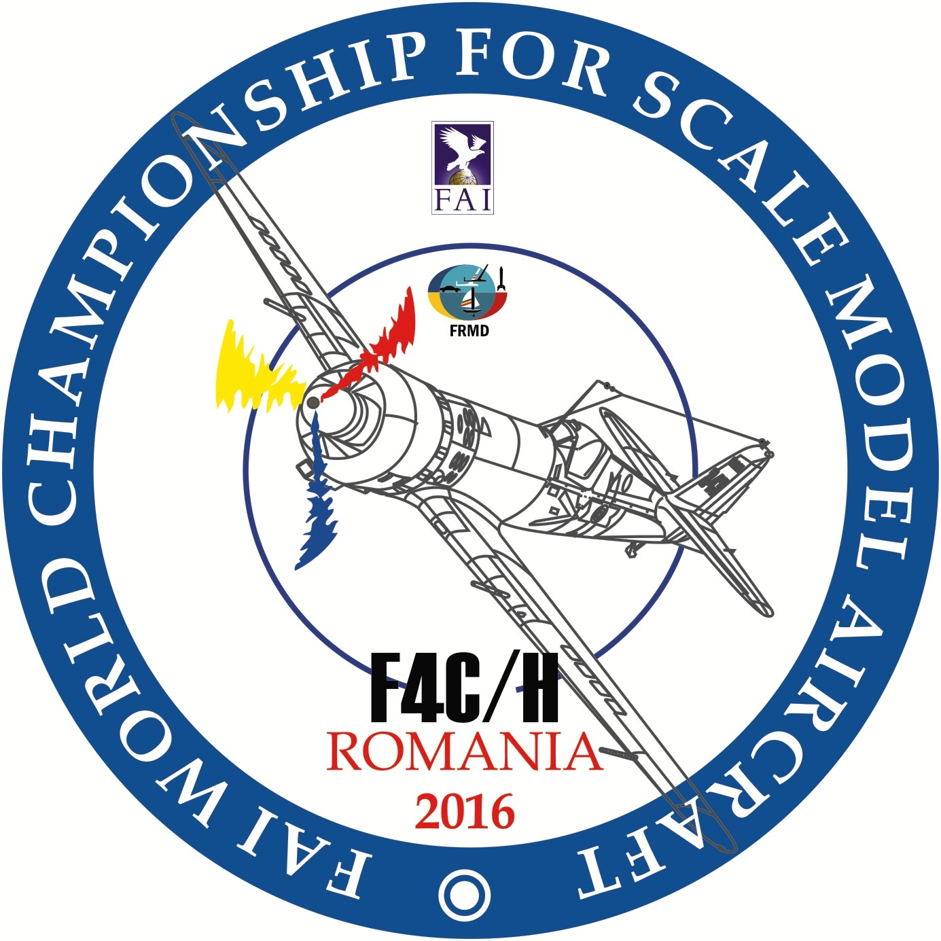

PRELIMINARY ENTRY FORM

NATIONAL AEROCLUB / FEDERATION OF __________________
CORESPONDANCE ADDRESS ______________________________
_____________________________________________________
_____________________________________________________
_____________________________________________________
_____________________________________________________
FAX:_________________________
PHONE______________________
E-mail: ______________________

NATIONAL TEAM F4C - team manager_____________
- Team manager’s assistant____
- senior competitors__________
- junior competitor___________
- helpers____________________
- supporters_________________
- 2014World Champion_______

F4H - team manager_____________
- Team manager’s assistant____
- senior competitors__________
- junior competitor____________
- helpers____________________
- supporters_________________
- 2014World Champion_______
- press representatives________
- TOTAL PERSONS__________

Fill in and return to:

ROMANIAN MODELLING FEDERATION
OP-6, CP-56
Bucuresti – Romania
Fax: +40-31-805.74.71
E-mail:; conumarius@gmail.com ; cringupopa@gmail.com

PLEASE RETURN BY, E-mail OR FAX UNTIL FEBRUARY, the 15th,, 2016

SIGNATURE & STAMP OF NAeC/FEDERATION

___________________

DATE _________________

