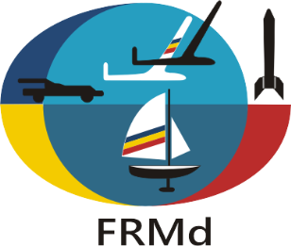

2022 FAI F1E EUROPEAN CHAMPIONSHIP FOR FREE FLIGHT
MODEL AIRCRAFT FOR SENIORS AND JUNIORS
08th - 11th of August 2022
TURDA, ROMANIA

PRELIMINARY ENTRY FORM

NATIONAL AEROCLUB / FEDERATION OF ________________________________________
CORESPONDANCE ADDRESS _____________________________________________________
_____________________________________________________
_____________________________________________________
_____________________________________________________
_____________________________________________________
FAX________________________________
EMAIL_____________________________
PHONE_____________________________

NATIONAL TEAM - team manager_____________
- team manager’s assistant___________
- senior male competitors__________
- senior female competitors__________
- junior male competitors___________
- junior female competitors___________
- 2018 European Champion senior_____
- 2018 European Champion junior (if still junior)_____
- helpers____________________
- supporters_________________
- timekeeper_________________
- press representatives_________
- persons in hotel_____________
TOTAL PERSONS______________

Fill in and return to: FEDERATIA ROMANA DE MODELISM
OP – 6, CP – 56
BUCURESTI, ROMANIA
TEL/FAX:+40-31-805 7471
E-mail: ioanaeu822@gmail.com

PLEASE RETURN BY E-MAIL, MAIL OR FAX UNTIL the 1st of April 2022.

SIGNATURE & STAMP OF NAC/FEDERATION

_________________________________________
DATE____________________________

