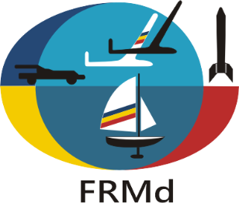

2022 FAI WORLD CHAMPIONSHIPS
FOR INDOOR MODEL AIRCRAFT, SENIORS AND JUNIORS
12th - 15th of December 2022, SLANIC, PRAHOVA, ROMANIA

PRELIMINARY ENTRY FORM

NATIONAL AEROCLUB / FEDERATION OF ________________________________________
CORESPONDANCE ADDRESS _____________________________________________________
_____________________________________________________
_____________________________________________________
_____________________________________________________
_____________________________________________________
EMAIL_____________________________
PHONE_____________________________

NATIONAL TEAM - team manager_____________
- team manager’s assistant___________
- senior male competitors__________
- senior female competitors__________
- junior male competitors__________
- junior female competitors__________
- 2018 World Champion senior_____
- 2018 World Champion junior (if still junior)_____
- helpers____________________
- supporters_________________
- timekeeper_________________
- press representatives_________
- persons in hotel_____________
TOTAL PERSONS______________

Fill in and return to: FEDERATIA ROMANA DE MODELISM
CALEA PISCULUI, Nr.10, SALA POLIVALENTA, Camera II-15
Sector 4, BUCURESTI, ROMANIA
TEL:+40-31-805 7471
E-mail: ioanaeu822@gmail.com

PLEASE RETURN BY E-MAIL UNTIL the 1st of August 2022 .

SIGNATURE & STAMP OF NAC/FEDERATION

_________________________________________
DATE____________________________

