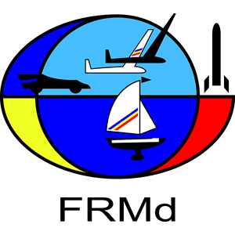

PRELIMINARY ENTRY FORM
2023 FAI F3K World Championship for Model Gliders
22th August – 1st September 2023, Sânpetru Brașov – Romania

NAC_______________________________________________________________________
Name: ____________________________________________________________________
Address: __________________________________________________________________
Phone: ________________________________e-mail:_____________________________

National team:
- Team Manager ____________
- Assistant Team Manager ____________
- No. of Senior Competitors F3K ____________
- No. of Female Competitors F3K ____________
- No. of Junior Competitors F3K ____________
- No. of Junior Female Competitors F3K ____________
- No. of Helpers / Supporter ____________
- Reigning Senior World Champion ____________
- Reigning Junior World Champion ____________
TOTAL PARTICIPANTS ____________

Date: ______________
Signature: ____________________ Official NAC Stamp ____________________

Preliminary Entry Form has to be sent before April 1st, 2023 via: e-mail: ioanaeu822@gmail.com

