|  |  |  |
| --- | --- | --- |
|  | **FEDERATIA ROMANA DE MODELISM ROMANIAN MODELLING FEDERATION** Member of FAI-CIAM, NAVIGA, FEMA, EFRA  Str. Calea Piscului nr. 10, Sala Polivalentă, cam II-15,  OP-6, CP-56, sector 4, Bucuresti - ROMANIA  Tel./Fax: +4021.316.24.54; +4031.805.74.71  Web : [www.frmd.ro](http://www.frmd.ro) ; E-mail: [office@frmd.ro](mailto:office@frmd.ro) | Description: http://www.frmd.ro/images/fai-logo.gif |

**2025 FAI F1D EUROPEAN CHAMPIONSHIPS FOR INDOOR MODEL AIRCRAFT, SENIORS and JUNIORS**

**November 24th-27th, 2025**

(Opening Ceremony to Closing Ceremony)

**Slanic Prahova, România**

**Information Bulletin No. 0**

**WEBSITE** <https://frmd.ro/international-competitions-in-romania/>

**CONTEST DIRECTOR:** Istvan Kiss, Romania

**ORGANISER AND LOCATION**

- Romanian Modelling Federation in cooperation with the City Council of Slanic Prahova and the SALROM Company.

- The field will be the same that was used for all of the F1D International Championships held in Salt Mine in Slanic. The field is very well known among F1D flyers and situated coming at 104 km away from Bucharest.

- The coordinates for contest site are: 45° 14′ 0″ N, 25° 56′ 21″ E.

- The underground Hall “UNIREA”, 70 m below Hall “Mihai”; Height: 56 m (Cat.IV); Length: 100 m; Width: 33 m; Average temperature: 11 degrees C.

- Access to Hall “Unirea” by minivans, provided by the salt mine company.

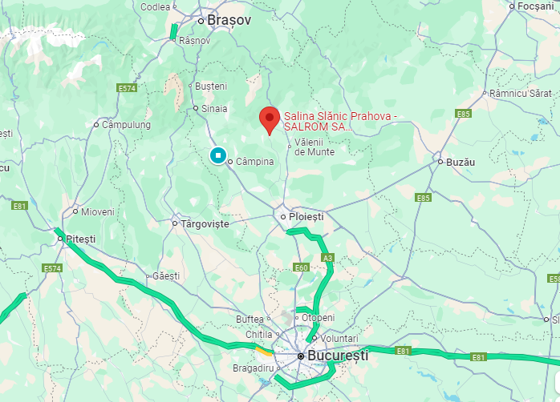

**RULES**

The championship will run according to:

- FAI Sporting Code Section 4

– Aeromodelling CIAM General Rules 2020 Edition FAI

- Sporting Code Section 4

– Aeromodelling Volume F1 Free Flight Model Aircraft 2020

- FAI Sporting Code General Section and FAI Code of Ethics 2020 Edition.

**Anti-Doping Statement:**

If a competitor has to take, by a medical condition, any of the substances listed on the WADA Prohibited List then he must have a Therapeutic Use Exemption from the FAI. www.wada-ama.org Quotation from the FAI anti-doping regulations: “If you regularly take medication prescribed by your doctor and this medication is on the WADA prohibited list, you need to get a form called a TUE (therapeutic use exemption) filled out by your doctor. International level athletes must send the form to the FAI Secretariat, national level athletes send it to their National Air Sport Control”.

**FAI Sporting License**: each competitor and team manager must possess a FAI Sporting License valid for the year of the championship. This license must be registered in the FAI licenses database.

NOTE: The holder of a FAI Sporting License may be required to produce an official document bearing his photograph and signature as proof of identity.

**OFFICIAL LANGUAGES** English and Romanian.

**FAI JURY:** Ree Andras (HUN), Antonis Papadopoulos (GRE), Szilard Szijjarto (ROU)

**COMPOSITION OF A NATIONAL TEAM**

Each National Aero-club/National Federation, member of the FAI-CIAM may enter a team consisting of:

- team manager, team manager assistant

- senior competitors: maximum 3 competitors or a maximum of 4 competitors if at least one competitor is female

- junior competitors (age limit 18 years in the year 2025): maximum 3 competitors or a maximum of 4 competitors if at least one competitor is female

- according to the FAI Sporting Code, the reigning senior World Champion

- according to the FAI Sporting Code, the reigning junior World Champion (referring to the CIAM General Rule 2020; sections C.5.1 and C.5.3. d)

- official helpers, supporters

**CLASSIFICATION AND AWARDS**

Individual classification FAI medals and FAI diplomas will be awarded to the competitors seniors and juniors placed first, second and third.

The championships winner earns the title of European Champion irrespective of the number of nations.

The reigning European Champion 2023 (subject to the approval of his NAC) to participate in the championship(s) in that class regardless of whether or not he qualifies for the national team. If he is not a member of the national team, his score or place will not be considered in the team results.

**Individual classification**

FAI medals and FAI diplomas will be awarded to the competitors seniors and juniors placed first, second and third. All senior Females will compete for the overall senior individual classification. Additionally, there is a senior Female classification both with FAI medals and diplomas.

All Junior Females will compete for the overall junior individual classification. Additionally, there is a junior Female classification both with FAI medals and diplomas.

FAI medals and diplomas will be awarded to the first, second and third overall juniors. If only one or two overall juniors, compete in the class, they shall be awarded an FAI medal and diploma.

FAI medals and diplomas will be awarded to the first, second and third placed females, junior or senior. If only one or two females, junior or senior, compete in the class, they shall be awarded an FAI medal and diploma.

In order to award the title of Junior European Champion, junior competitors from at least four nations must participate. In order to award the title of Senior Female European Champion, senior female competitors from at least four nations must participate.

In order to award the title of Junior Female European Champion, junior female competitors from at least four nations must participate.

The reigning European Champion 2023 (subject to the approval of his NAC) to participate in the championship in that class regardless of whether or not he qualifies for the national team. If he is not a member of the national team, his score or place will not be considered in the team results.

**Team classification**

FAI medals and FAI diplomas will be awarded to each member (including three competitors with the best results and the team manager) of the teams placed first, second and third.

**Other awards**

The Organizer will offer trophies to all the competitors in the team and the team manager.

**SCHEDULE**

November 21, Arrival Day

November 22, Memorial OTTO HINTS, rounds 1-3

November 23: Practice Day, Opening Ceremony, Technical meeting

November 24: Rounds 1 and 2

November 25: Rounds 3 and 4

November 26: Rounds 5 and 6, Award and closing Ceremony, Banquet

November 27, Monday: Departure Day

**PROTESTS**:

All protests must be presented in writing to the Contest Director at the competition site and must be accompanied by a deposit of 50 Euro. The deposit is to be returned if the protest is upheld only.

**ENTRY FEES**

€ 300 + CHF 10 per Senior Competitor, Team Manager

€ 250 + CHF 10 per Junior Competitor, Assistant Team Manager

€ 100 per Supporter, Helper

**DEADLINES**

Preliminary Entry Form should be sent to the Organizers no later than the 1st of September 2025.

Final Entry Form (to be sent with Bulletin 2) and the Entry Fees should be sent no later than the 1st of October 2025.

Payments sent after October 1, 2025, shall include a 10% surcharge.

Payments sent after November 1, 2025, shall include a 15% surcharge.

Payments sent after December 1, 2025, shall include a 20% surcharge.

**The bank commission is in charge of sender.**

BANCA ROMANA PENTRU DEZVOLTARE (www.brd.ro/en)

SUCURSALA BATISTEI, Str. Batiștei nr. 26, Sector 2, Bucuresti

COD SWIFT: BRDE ROBU

IN BEHALF OF: FEDERATIA ROMANA DE MODELISM

ACCOUNT IBAN: RO42BRDE410SV18443524100

TITLE: ECH F1D ENTRY FEES

**Banquet** 50 EURO/senior; 40 EURO/junior.

**INSURANCE**

The organizer will provide a limited third-party liability insurance covering all competitors for model accidents involving injury to others and damage to property. It is recommended that individual health and travel insurance is purchased before travelling. For EU citizens, health care is covered under Social Health Care on presentation of an EU 11 form available in the country of residence. Citizens from outside of EU should provide their own health insurance to cover illness and travel insurance. The Organizers are not responsible for any kind of PERSONAL injury, loss, theft or damage to people or property OUTSIDE OF THE COMPETITION. The Organizers will cover third party damage duringthe contest.

**Visa requirements**

For those countries where the Romanian Entry Visa is asked for, it can be obtained from The Romanian Embassies/Consulates.

For more information, please consult the Romanian Ministry of Foreign Affairs. (www.mae.ro/en/node/2040)

Citizens belonging to the countries members of EU do not need an Entry Visa.

**Registration of the national teams**

On registration, the Team Manager must present the FAI licenses, an updated entry form (if any changes), a national flag (1m x 1,5m), national anthem on memory stick, and the payment order only if paid late.

Romania is a Schengen Member Country.

**Transportation**

The organizer will provide free transportation for the members of the FAI jury. For teams, at their request, for the amount of 10 euros / person from the international Airport "Henri Coandă" to Slanic Prahova, on November 21th at an hour that will be established after registration we can provide transfer. Also, transportation from the town to Mina Unirea is free of charge for all participants hosted by the organizer.

**ORGANISER CONTACT DETAILS:**

**Mail**: FEDERATIA ROMANA DE MODELISM, Calea Piscului, nr.10, Sector 4,

SALA POLIVALENTA, camera II-15, BUCURESTI, ROMANIA

**Szilard Szijjarto**

Vicepresident of FRMd

0040 733106745

[szijjartoszilard@yahoo.com](mailto:szijjartoszilard@yahoo.com)

**We are looking forward to welcome you all in Slanic Prahova!**

**National Airsports Control NAC:**

**Romanian Modelling Federation**