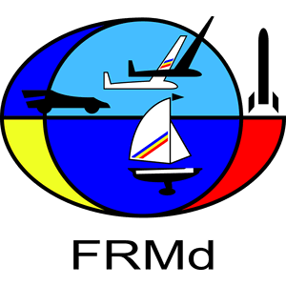 | FEDERATIA ROMANA DE MODELISM  ROMANIAN MODELLING FEDERATION  Member of FAI-CIAM, NAVIGA, FEMA, EFRA  Str. Calea Piscului nr. 10, Sala Polivalentă, cam II-15,  OP-6, CP-56, sector 4, Bucuresti - ROMANIA  Tel. +40744 659 000  Web : www.frmd.ro ; E-mail: office@frmd.ro; | 

2026 FAI F1E EUROPEAN CHAMPIONSHIPS FOR FREE FLIGHT
SLOPE SOARING GLIDERS FOR SENIORS AND JUNIORS
15th - 18th of July 2026
(Opening Ceremony to Closing Ceremony)
RUPEA, ROMANIA

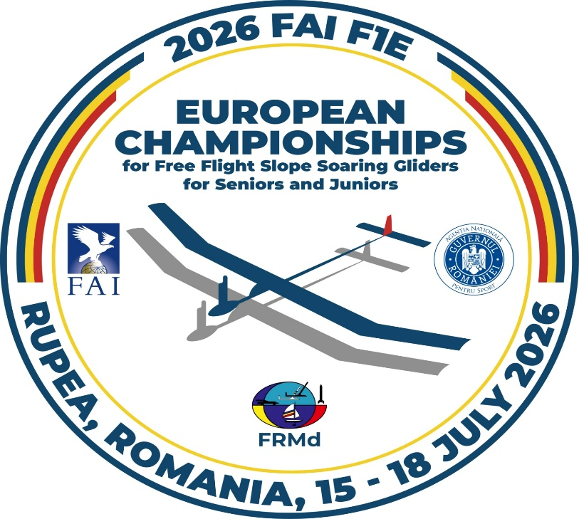

Information Bulletin No. 1

- ORGANISER
Romanian Modelling Federation
- PLACE
Rupea, Romania
- DATE OF CONTEST
15.07.2026 (Opening Ceremony) – 18.07.2026 (Closing Ceremony)
- WEBSITE
www.frmd.ro

- FAI JURY:
- To be nominated - President of the FAI Jury
- Bernhard SCHWENDEMAN - Jury Member
- Mr. Corneliu MANGALEA, Romania - Jury Member
- To be nominated - Jury reserve
- Mr. Mihail ZANCIU – Jury reserve, Romania

- ORGANIZING COMNITTEE ORESIDENT:
- Mr. Szilard SZJJIARTO

- CONTEST DIRECTOR:
- Viorel SALISTEANU

- Timekeeper DIRECTOR
- Mr. Istvan KISS, Romania

- OFFICIAL LANGUAGES
English and Romanian.

- ORGANISER AND LOCATION
- The Romanian Modelling Federation, in co-operation with City Hall of Rupea.
- The contest site is owned by the City Hall of Rupea and is situated at a distance of 64 km away from Brasov. The city of Brasov is localized at 170 km distance from “Henri Coanda” Bucharest International airport on National Road no. 1.
GPS coordinates for location: 46.044779, 25.216833
- Weather forecast at the end of July is usually good for F1E Class with an average daily temperature of 30C and moderate wind speed of 2-6 m/s and no more than a short summer rain weekly.

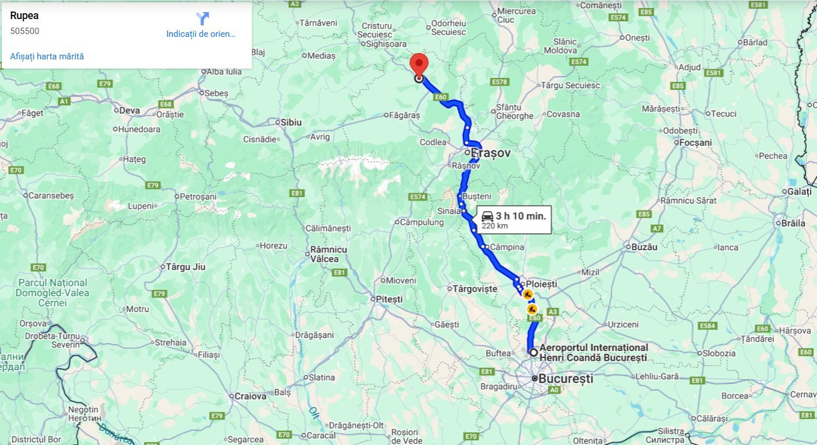

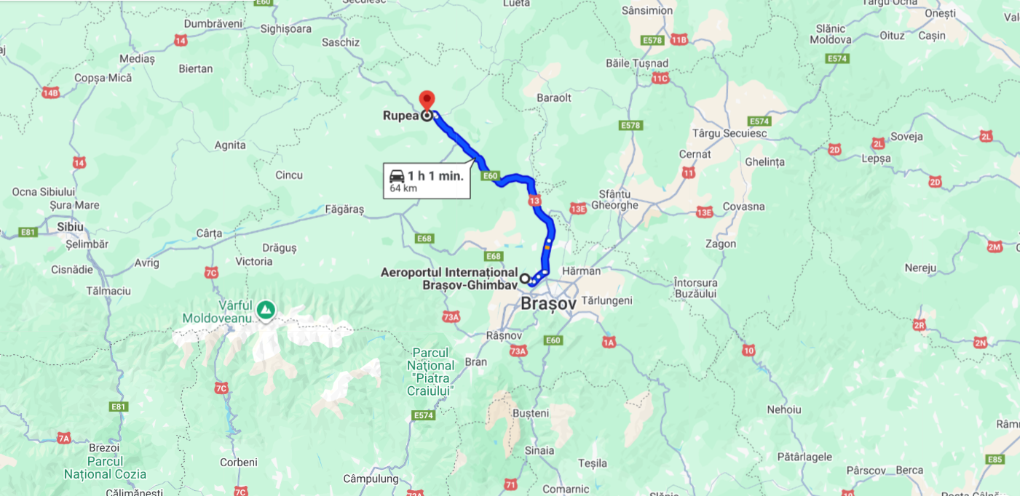

- CLASSES
Seniors: F1E
Juniors: F1E

- RULES
The championships will be run according to:
- FAI Sporting Code 2026 edition, CIAM General Rules and Volume F1.
- FAI General Section and FAI Code of Ethics.
Anti-Doping Statement:
If a competitor has to take, by a medical condition, any of the substances listed on the WADA Prohibited List then he must have a Therapeutic Use Exemption from the FAI.
www.wada-ama.org
Quotation from the FAI anti-doping regulations: “If you regularly take medication prescribed by your doctor and this medication is on the WADA prohibited list, you need to get a form called a TUE (therapeutic use exemption) filled out by your doctor. International level athletes must send the form to the FAI Secretariat, national level athletes send it to their National Air Sport Control”.

FAI Sporting Licence: each competitor and team manager must possess a FAI Sporting Licence valid for the year of the championship. This licence must be registered in the FAI licences database.
Note: The holder of a FAI Sporting Licence may be required to produce an official document bearing his photograph and signature as proof of identity.

- COMPOSITION OF A NATIONAL TEAM
Each National Aero-club/National Federation, member of the FAI-CIAM may enter a team
consisting of:
- team manager, team manager assistant
- senior competitors: maximum 3 competitors or a maximum of 4 competitors if at least one
competitor is female;
- junior competitors (age limit 18 years in the year 2026): maximum 3 competitors or a
maximum of 4 competitors if at least one competitor is female;
- according to the FAI Sporting Code, the reigning senior European Champion
- according to the FAI Sporting Code, the reigning junior European Champion (referring to the CIAM General Rule 2026; sections C.5.1 and C.5.3. d);
- official helpers, supporters.
- CLASSIFICATION AND AWARDS
Individual classification
FAI medals and FAI diplomas will be awarded to the competitors seniors and juniors placed first, second and third. All senior Females will compete for the overall senior individual classification. Additionally, there is a senior Female classification both with FAI medals and diplomas. All Junior Females will compete for the overall junior individual classification. Additionally, there is a junior Female classification both with FAI medals and diplomas. FAI medals and diplomas will be awarded to the first, second and third overall juniors. If only one or two overall juniors, compete in the class, they shall be awarded an FAI medal and diploma. FAI medals and diplomas will be awarded to the first, second and third placed females, junior or senior. If only one or two females, junior or senior, compete in the class, they shall be awarded an FAI medal and diploma. In order to award the title of Junior European Champion, junior competitors from at least four nations must participate. In order to award the title of Senior Female European Champion, senior female competitors from at least four nations must participate. In order to award the title of Junior Female European Champion, junior female competitors from at least four nations must participate. The reigning European Champion 2024 (subject to the approval of his NAC) to participate in the championship in that class regardless of whether or not he qualifies for the national team. If he is not a member of the national team, his score or place will not be considered in the team results.

FAI Trophies
Perpetual trophies will also be awarded:
- Serbian-France challenge perpetual trophy for F1E Junior Team.

Team classification
FAI medals and FAI diplomas will be awarded to each member (including the fourth competitor and the team manager) of the teams placed first, second and third.

Other awards
The Organizer will offer medals and trophies to the first three in individual and team classification (including the Team Manager).

- SCHEDULE
- 14.07.2026 Tuesday:
World Cup “Memorial Popa Cringu”
08:00 – 15:00 – Round 1 to Round 5
18:00 – 21:00 – Fly off
21:00 – Award Ceremony World Cup

- 15.07.2026 Wednesday:
07:00 – 16:00 – Practice, Final Registration, Model processing
18:00 – Open ceremony (Place to be nominated)
19:00 – Technical meeting

- 16.07.2026 Thursday:
European Championship for Juniors
07:00 – 16:00 – Round 1 to Round 7
18:00 – 21:00 – Fly off

- 17.07.2026 Friday:
European Championship for Seniors
07:00 – 16:00 – Round 1 to Round 7
18:00 – 21:00 – Fly off

- 18.07.2026 Saturday:
Meteo reserve day/trip, prize awarding and closing ceremony and Banquet
18:00 – Award Ceremony plus Closing Ceremony
20:00 – Banquet

- 19.07.2026 Sunday:
World Cup “Rupea World Cup” or departure of participants
08:00 – 15:00 – Round 1 to Round 5
18:00 – 21:00 – Fly off
21:00 – Award Ceremony World Cup

- PROTESTS:
All protests must be presented in writing to the Contest Director at the competition site and must be accompanied by a deposit of 50 Euro. The deposit is to be returned if the protest is upheld only.

- ENTRY FEES
€ 350 per Senior Competitor, Team Manager, Assistant Team Manager
€ 300 per Junior Competitor
€ 70 per Supporter, Helper, Spectator
€ 50 World Cup per Senior
€ 40 World Cup per Junior
€ 11 (10 CHF) Sanction Fees for FAI-CIAM (Competitor, Team Manager, Assistant Team Manager)
€ 50 Banquet for Senior
€ 40 Banquet for Junior
€ 15 Lunch on site per person, per day

- DEADLINES
Preliminary Entry Form should be sent to the Organizers no later than the 30th of March, 2026.
Final Entry Form should be sent to the Organizers no later than the 30th of April, 2026
At the same time, the Entry Fees for Team Manager, Team Manager’s Assistant, Senior competitors, Junior Competitors, Helpers, Supporters, should be sent to the following bank account no later than the 30th of April 2026.

BANCA ROMANA PENTRU DEZVOLTARE (www.brd.ro/en)
SUCURSALA BATISTEI, Str. Batiștei nr. 26, Sector 2, Bucuresti
COD SWIFT: BRDE ROBU
IN BEHALF OF: FEDERATIA ROMANA DE MODELISM
ACCONT IBAN: RO42BRDE410SV18443524100
TITLE: ECH F1E ENTRY FEES
Payments sent after the 30th of April will be subject of a fine:
1st of May – 31st of May: 10% fine
1st of June – 30th of June: 15% fine
1st of July – 14th of July: 20% fine
The bank commission is in charge of sender.

- BOARD AND LODGING
The Organizer will not provide lodging.
Rupea is a touristic and cultural city in center of Romania and has plenty of accommodation units.
We recommend you to use the below websites in order to book your accommodation:
https://hotelscan.com/en
www.booking.com

- INSURANCE
The organiser will provide a limited third-party liability insurance covering all competitors for model accidents involving injury to others and damage to property.
It is recommended that individual health and travel insurance is purchased before travelling.
For EU citizens, health care is covered under Social Health Care on presentation of an EU 11 form available in the country of residence.
Citizens from outside of EU should provide their own health insurance to cover illness and travel insurance.
The Organizers are not responsible for any kind of PERSONAL injury, loss, theft or damage to people or property OUTSIDE OF THE COMPETITION.
The Organizers will cover third party damage during the contest.

- Bulletin 2
Bulletin no. 2 will be published before MAY 15, 2026.

- Bulletin 3
Bulletin no. 3 will be published before JUNE 14, 2026

- UAS regulations:
In Romania, a senior UAS (Unmanned Aircraft System) pilot cannot benefit from other privileges than those offered by the proof of completion of the online theoretical training (A1/A3) or the theoretical knowledge certificate for the remote pilot (SPEC); exceptions are those who carry out operations: in the INDOOR classes, with unmanned aircraft of the physically restricted classes, with unmanned aircraft with an MTOM of less than 250 grams or with a toy, as defined in Directive 2009/48/EC.
A junior UAS pilot may be privileged to conduct UAS operations without being registered with the AACR (Romanian Civil Aeronautics Authority) and without holding proof of completion of online training (A1/A3)/remote pilot theoretical knowledge certificate (SPEC) under direct supervision of the coach or an adult who holds proof of training for the respective category.
The practical training of remote pilots from other countries, who participate in the international competitions organized in Romania, is carried out on the first day of the competition, dedicated to this purpose (training day). The proof of completion of theoretical training and the Certificate of theoretical knowledge for remote pilot (SPEC) obtained by athletes in the countries from which they come, will be recognized by the Romanian Modelling Federation and the Romanian authorities.
In conclusion, in accordance with the Procedure of the Romanian Modelling Federation for the training of UAS pilots, all participating seniors and junior Team Managers must provide proof of online theoretical training. The practical training for the flight in the "SPECIFIED" category, at a height higher than 120 m, will be done on the official training day. Then, the Romanian Federation of Modeling issues for each senior or TM/coach of juniors, a Certificate that you can use at all international model aircraft competitions in Romania, for any competition category. The price for issuing the Certificate is 10 euros.
Visa requirements
For those countries where the Romanian Entry Visa is asked for, it can be obtained from The Romanian Embassies/Consulates. For more information, please consult the Romanian Ministry of Foreign Affairs. (www.mae.ro/en/node/2040)
Citizens belonging to the countries members of EU do not need an Entry Visa.
Registration of the national teams
On registration, the Team Manager must present the FAI licenses, an updated entry form (if any changes), a national flag (1m x 1,5m), national anthem on CD or on memory stick, and the payment order only if paid late.
Model Aircraft Specification Certificates will be required for processing.

- Transportation
The organizer will provide the transport for teams at their request, from the international airport "Henri Coandă" Bucharest to Rupea. The transport price is 60 euros / pers.

- NATIONAL CURRENCY
1 LEU=100 BANI
There are banknotes of 1 LEU, 5 LEI, 10 LEI, 50 LEI, 100 LEI, 200 LEI and 500 LEI.
There are coins of 1, 5, 10 and 50 bani.

- MONEY EXCHANGE: we strongly recommend to exchange money only at the cash machines, exchange offices and banks.

- EXCHANGE RATE: 1 EUR= 5,06 LEI

- FUEL PRICE:
1l 95 octane (with or without led) ~8,00 LEI
1l 98 octane (with or without led) ~8,50 LEI
1l Diesel ~ 8,00 LEI

- ORGANISER CONTACT DETAILS

Mail: FEDERATIA ROMANA DE MODELISM
OP 6 – CP 56 BUCURESTI, ROMANIA
Email: office@frmd.ro

We are looking forward to welcome you all in Rupea!

THE ORGANIZING COMMITTEE,
Secretary General,
Corneliu MANGALEA

